Frequently Asked Questions

The structural and organisational impacts of perioperative enhanced care services in the UK:
A Retrospective Evaluation of Post-operative Alternatives to Critical Care (REPACC)

Pan-London Perioperative Audit & Research Network

IRAS Project ID: 338772

Correspondence
Chief Investigator (CI):
Dr Christopher Oddy

Department of Anaesthesia
Kingston Hospital
Galsworthy Rd
Kingston upon Thames
KT2 7QB

Email: repacc.plan@gmail.com

1. Who is running REPACC?
REPACC is being run by a trainee research network known as the Pan-London Perioperative Audit & Research Network (PLAN). The lead site is Kingston Hospital.

2. When will data collection take place?
Data collection will begin in March 2024 and will run over an estimated 6-month period. As all of the data collection is retrospective, covering the period between 01/09/23-31/11/23, there is no formal start or end date for this process.

3. What are the objectives of REPACC?
- To describe the current models of enhanced care operational within the UK.
- To identify the structural and organisational factors associated with rate of on-the-day cancellation due to lack of an enhanced care bed space.
- To evaluate the effect of different models of enhanced care on wider measures of organisational efficiency.

4. How do I get involved?
Our protocol and materials will be distributed via local trainee research networks (TRN). Local leads will be identified through this process, however, if your local TRN is unable to support this process it is still possible to run this study at your site! If you are interested in running this study at your institution then please contact the study management group on repacc.plan@gmail.com. We can send you and your team all of the materials required to get you set up and can provide support and guidance in running it.

5. Will I receive acknowledgement of my involvement?
Of course! All local investigators will be recognised on any future publications as collaborative authors. In addition, you will receive a certificate confirming your involvement that can be used as evidence for both research and quality improvement domains of your professional portfolio. Trainee leads will be recognised as local lead investigators on their certificates.

6. How many people need to be involved at each site?
We recommend that each site has a lead consultant, a trainee lead, and – depending on the size of your hospital – between 1 and 3 additional team members. The lead consultant should be able to assist with completing the survey component of the study. In particular, it may be useful to involve the perioperative lead at your site to supervise.

7. How long does the data collection process take?
In total it is expected for the process of data collection to take between 1 and 2 months depending mostly on how quickly the clinical informatics team at your site is able to generate their datasets. The total time commitment for investigators is expected to be as follows:
- Trainee lead – 3-4 full days with some additional time spent emailing and coordinating.
- Consultant lead – <1 full day.
- Trainee investigators – 1-2 full days of data collection.
This can be broken down into several stages that will vary slightly in duration depending on the size of your centre:
- Project setup:
  - Registration with clinical governance – usually a short form (~1hr) and a wait time dependent on how busy the governance team is.
  - Organisational survey – 2-4hrs, this process can run in tandem with the rest of the data collection process.
- Time-series data:
  - Record the daily referrals to enhanced care – roughly 1 half day of recording from a diary, database or email chain.
  - Coding data for daily operations, cancellations and admissions – the data collection guide should be fairly self-explanatory to the clinical informatics team, this process may require some clarification and will expectedly take 1-2 weeks but will require minimal trainee input.
- Clarification and capture of referrals and admissions:
  - Identify cancellations due to a lack of enhanced care bed – this process requires looking through the notes of on the day cancellations to clarify if this was due to a lack of enhanced care bed, 1 half to 1 full day.
  - Identify planned admissions not captured by 2a – this process requires looking through the notes of admissions to each level of enhanced care to see if these were planned admissions but were not identified by 2a, 1 half to 1 full day.
- Consolidation of final cohort – this is performed automatically by the time series CRF and should be a matter of copying and pasting from one spreadsheet to another.
- Per patient data:
  - Coding data – as before, the data collection guide should be fairly self-explanatory to the clinical informatics team, this process may require some clarification and will expectedly take 1-2 weeks but will require minimal trainee input.
  - Collected data – 4 pieces of information are collected for each patient referred to enhanced care pre-operatively, 1 full day.
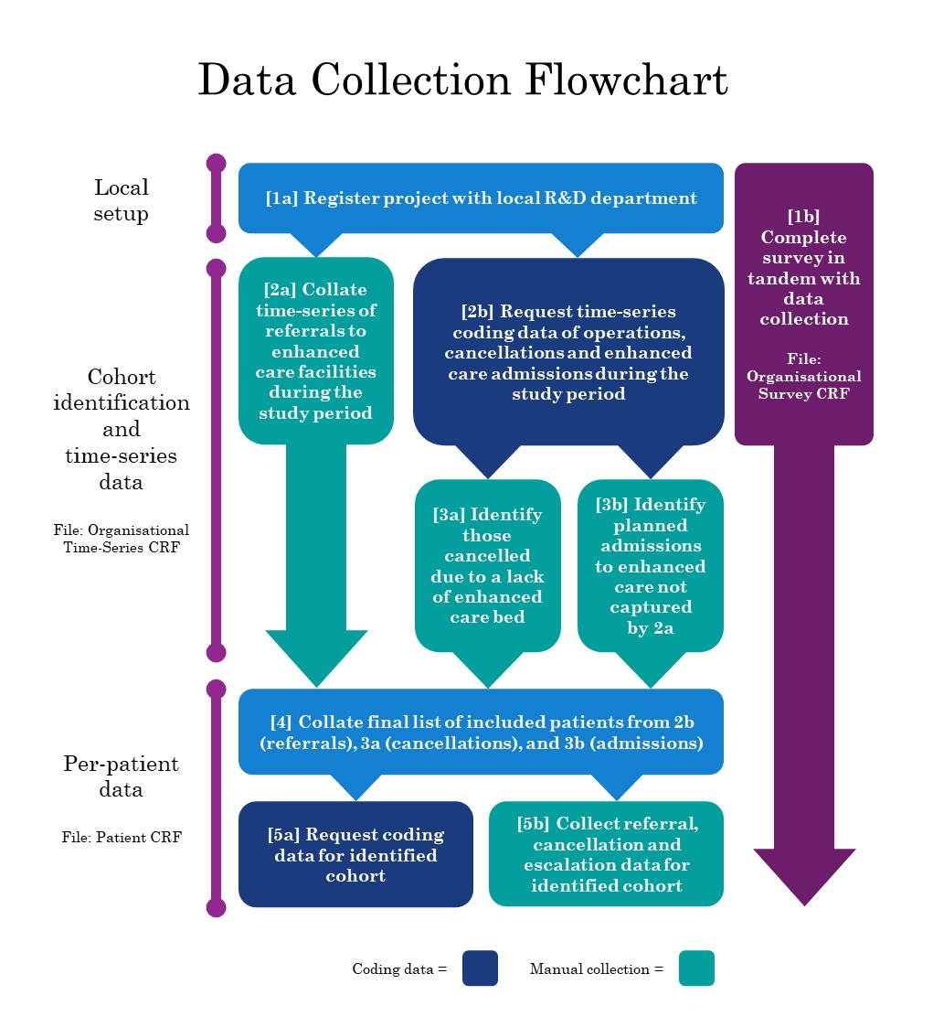
A data collection guide is available that provides step-by-step guidance on how to run the data collection process which is summarised in the following flowchart.

8. Is patient consent required to collect the data?
No, this project is being run as a service evaluation. All recorded information is anonymised, and personally identifiable information will only be accessed by the direct care team, therefore, patient consent will not be sought. Local investigators are not required to have completed Good Clinical Practice (GCP) certification.

9. Is ethical approval required at my site?
No, REPACC is registered as a service evaluation and therefore does not require ethical approval.

10. How will data be stored and shared?
Anonymised data will be shared between NHS email accounts only. No personally identifiable information will be recorded, however documentation linking hospital to study IDs should be stored on encrypted drives as specified in the protocol. Please refer to the protocol and data collection guide for a full description of our information governance measures.

11. My hospital doesn’t have a PACU/OIR, can I still be involved?
Absolutely! We are interested in seeing what happens in hospitals with and without these models of care. Our analysis will be much more interesting if we can compare sites without these units to those that have them.

11. My hospital has several areas that deliver each level of care, how do I manage this?
If each area of care – i.e. if you have several PACUs (level 1), HDUs (level 2), or ICUs (level 3) – provided they admit general surgical patients, please aggregate all referral and admissions data for each level of care. For example, your hospital may have three level 3 units, a general ICU, cardiac ICU and neuro ICU. In this example your general ICU and cardiac ICU will accept general surgical patients for post-operative care but your neuro ICU will not. In this case please collect referral and admissions data for your general and cardiac ICUs, but not for neuro ICU, and aggregate the data.

11. My hospital only uses paper notes, how do I approach the data collection process?
We have provided some tips on how to approach this in our site setup guide. The main modification is to perform all of the note appraisal at the same time, which means several stages the data collection process are performed in tandem.

